LAND USE IMPACTS ON MANGROVE FISH ASSEMBLAGES: IMPLICATIONS FOR CONSERVATION OF COASTAL RESOURCES IN THE INNER GULF OF THAILAND

Siraprapha Premcharoen, Faculty of Liberal Arts and Science, Kasetsart University, faassrp@ku.ac.th
Sutanun Kiat-amornwet, Faculty of Liberal Arts and Science, Kasetsart University, n_a_n_sk@hotmail.com

Abstract. Fish assemblages as reflected from coastal land use in mangrove estuary of
Ban Laem District, Phetchaburi Province, Inner Gulf of Thailand had been conducted seasonally during December 2012 and October 2013. Samplings were conducted in blood cockle farms, public benefit channel, mangrove fringe area and Ban Laem estuary, using a push net at both day and night. A total of 29,287 individuals belonging to 11 orders 33 families and 54 species were collected. The Carangidae was by far the most speciose (6 species), with Arius maculatus numerically dominating (15,989 individuals, 54.59%). The highest number of individual was recorded in mangrove fringe area (21,051 individuals, 71.88%) in May (18,642 individuals, 63.65%) at day catches (22,149 individuals, 75.63%). The highest value indices of diversity, richness and evenness were 2.59, 3.65 and 0.88 respectively, recorded in mangrove fringe area in October. ANOSIM analysis showed a clearly significant difference of species compositions and abundance among sites, seasons and between day and night (p=0.001). Catches consisted primarily of juveniles or small-sized fishes, indicating that the area is important as a nursery ground. The findings of this study have implications for the conservation and management of mangrove and fisheries resources in Ban Laem and adjacent areas in the inner Gulf of Thailand.

Key words: Gulf of Thailand, mangrove fish

I. INTRODUCTION
Mangrove ecosystems are important to the sustainable economic development of coastal fisheries. They are extremely productive systems that support rich assemblages of juvenile fishes and invertebrates, and maintain commercial offshore stocks of fish [1, 2]. Several studies of mangrove fish communities in Thailand provide evidence that Thai mangroves play important roles in maintaining and improving estuarine water quality and play crucial roles in the life cycle as breeding ground or nursery ground for many commercially important fish species [1, 3]. These areas are often characterized by high biomass and contain abundant and diverse assemblages of fish, with 87 families and 607 species of estuarine fish documented in Thailand [4].
During this century, large areas of mangrove forests are heavily impacted by various forms of exploitation and conversion to other uses, with coastal development of which conversion to shrimp ponds (64% by area in 1986) is one of the most serious in Thailand [5], only 0.45% of mangrove forests remains in the inner part of the Gulf [6]. Ban Laem coastal area, one of the most productive fishing areas in the inner Gulf of Thailand are threatened by land-use conversions, especially converted to shrimp farming and blood cockle culture [7], along with industry, agriculture and urbanization effluent into the Ban Laem and Bang Taboon estuaries represent environmental problems.
Despite the importance of mangroves as noted above, there has been relatively few studies on fish assemblages in relation to mangrove in Southeast Asia including Thailand [8-12], so that mangrove utilization by fishes is poorly understood [13]. In order to give a better insight into the importance of mangrove to fish in order to facilitate the incorporation of the ecologically important species into ecosystem-based management, the main aim of this study was to investigate the land utilization, seasons and change of time (day/night) which affect the patterns of fish community structure in the Ban Laem mangrove estuary.

II. MATERIAL AND METHODS

Study area
Sampling was performed at Ban Leam coastal area (13° 12′ 2″ N, 99° 58′ 49″ E), intertidal mangrove-fringed located in northeastern part of Phetchaburi Province, Thailand (Fig. 1). The area experiences tropical climatic conditions, dominated by the southwest monsoon, classified into three seasons; rainy season (wet; May–November), winter (cool and dry; December–February), and summer (hot and dry; March–April). According to statistics for 2009, the average temperatures were 27.7, with a total of 104 rainy days, average humidity 77% and average precipitation being 853 millimeters. Ban Laem is one of the most productive fishing areas with freshwater, saltwater, and brackish water. The estuarine ecosystems by influence of the currents that blow the deposition of mud lane, with a vast area of mangrove forest along the shoreline on the side of the river mouth. Common species of mangroves in the area are Rhizophora apiculata, R. mucronata, Avicennia alba, A. marina, Bruguiera gymnorrhiza, B. cylindrical, Sonneratia caseolaris, S. ovate, Excoecaria agallocha and Nypa fruiticans [7].

Collection of fish samples
Four sampling sites (Fig. 1) were selected based on different land uses (blood cockle farms: BT1, public benefic channel: BT2, mangrove fringe area: BL1 and Ban Laem estuary: BL2). Samplings were conducted in December 2012 (winter/dry season), March 2013 (summer/hot season), May 2013 (early rainy season) and October 2013 (late rainy season) at high tides in both day and night. At each site, duplicate samples were collected with a push net. All parameters (depth, temperature, dissolved oxygen, salinity, and pH) were measured at the same times and places in which sampling occurred at a depth of approximately 30 cm below the surface.
Fish caught were instantly preserved in 10% formaldehyde and transported to the laboratory for analysis. In the laboratory, all fish were sorted, identified to species level according to [14] counted, standard length was measured to the nearest 1 mm and wet-weight was determined to the nearest 0.1 g.

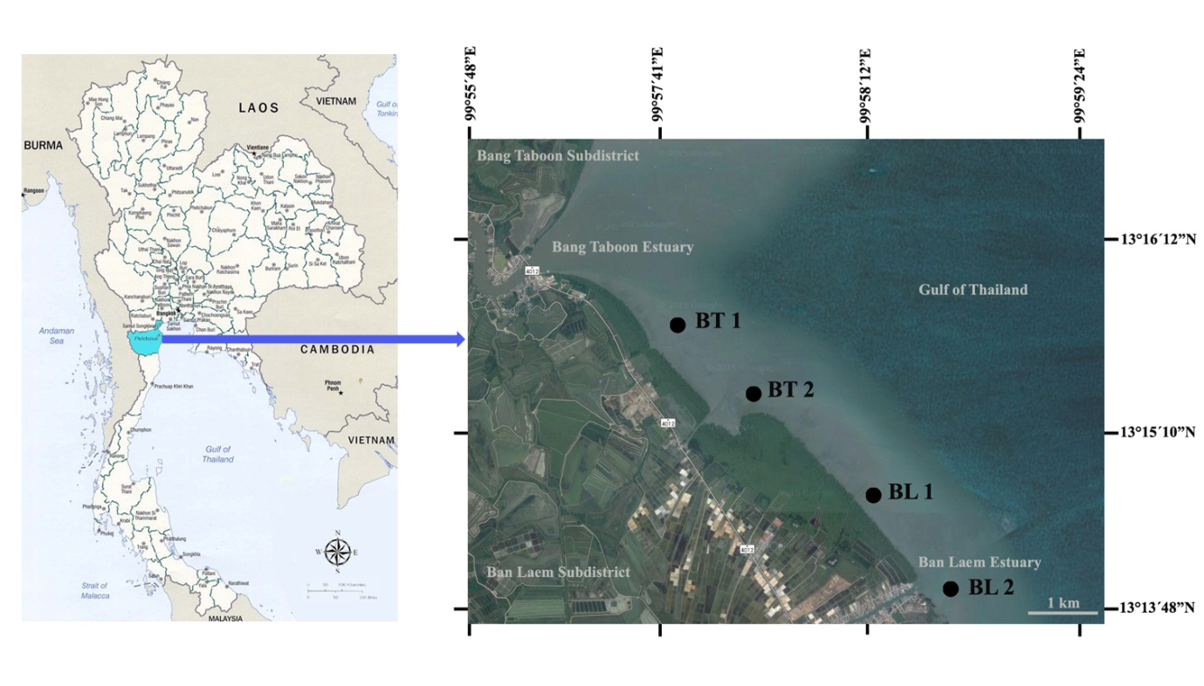

Fig. 1. Ban Laem coastal area, Inner Gulf of Thailand, showing location of sites ( ) from which fish samples were collected.

BT1 (13° 14′ 3″ N, 99° 59′ 62″ E): The boundary area between Samut Songkhram Province and Bang Taboon Subdistrict, Ban Laem District, Phetchaburi Province. Many blood cockle farms and oyster farms have been established along the coast of this area.
BT2 (13° 14′ 2″ N, 99° 59′ 61″ E): The boundary area between Bang Taboon Subdistrict and Ban Laem Subdistrict. It is the public benefit channel, surrounded by the abundant of blood cockle farms. This site situated about 300 m away from the mangrove shore.
BL1 (13° 14′ 2″ N, 99° 59′ 62″ E): Natural mangroves (>25 yrs.) and planted mangroves (5-10 yrs), dominated by Rhizophora spp. This area is not for public use.
BL2 (13° 13′ 4″ N, 99° 59′ 81″ E): Mangroves in this area have been cleared for urbanization. A few of Rhizophora spp. (~5 yrs) still exist. This area is closed to Phetchaburi River which flow into the Gulf of Thailand

Fish assemblages analysis
Species composition and abundance including ecological indices (diversity, richness and evenness) were analysed. The degree of similarity among fish assemblages among sites, seasons and between time of day was explored by classification and ordination using the statistical package, PRIMER (Plymouth Routines In Multivariate Ecological Research) version 5.2.9 [15]. Analysis of similarity (ANOSIM) was used to determine whether fish assemblages separated a priori into sites, seasons and day or night differed statistically.

III. Results and discussion

Species composition and abundance
Overall, 29,287 individuals belonging to 11 orders 33 families and 54 species were collected in the Ban Laem coastal area (Table 1). The Carangidae was by far the most speciose (6 species), followed by Clupeidae (5 species) and Leiognathidae (4 species). The majority of fish families found in this study are commonly known to inhabit mainly mangrove estuaries and saltmarshes. These fishes include mainly the anchovies (Engrualidae), herrings (Clupeidae), ariid catfishes (Ariidae), mullets (Mugilidae), silversides (Atherinidae), ponyfishes (Leiognathidae), perchlets (Ambassidae), drums (Sciaenidae), and gobies (Gobiidae), consistent with previous studies in Thailand [6, 10, 16-17], and mangrove estuaries in other tropical countries [2, 8, 18]. Many rare species (5 species in total) were recorded, with numbers of less than 5 individuals. Of all the species sampled, 25 species (25,005 individuals, 85.38%) are considered to be residents of the mangroves, commonly found in the estuary over the period of the study. Thirty one species (57.41% of all species) are considered to be of economic importance. These diverse fish assemblages have a high value for the local subsistence fishing [19]. Most of the species collected were juveniles or small-sized fishes, being dominated by engraulids, clupeids, ariids, mugilids, ambassids, leiognathids and sciaenids. These are known to use habitats during their juvenile life stages [20]. Therefore, the present results support the view of mangrove estuaries serving as important nursery habitats for many fish species.
The ten most abundant species accounted for 91.73% of the total number of individuals collected. Of all the species caught, ariid catfish (Ariidae) dominated the most abundant families, with Arius maculatus numerically dominating (15,989 individuals, 54.59 %), followed by Eubleekeria splendens (3,681 individuals, 12.57%), Ambassis gymnocephalus (1,892 individuals, 6.46%), Nuchequula gerreoides (1,828 individuals, 6.24%) and Stolephorus commersonnii (1,008 individuals, 3.44%). The highest number of individuals was recorded in mangrove fringe area (21,051 individuals, 71.88%).
Estuarine fish can be classified into various groups based on ecological affinity [21]. Accordingly, the species listed from the study in Table 1 were classified into the two main affinity groups; (1) truly estuarine species which spend their entire lives in the estuary, they are year-round residents, commonly found throughout the estuary because they can tolerate a wide range of salinity (2) estuarine –marine species which use the estuary primarily as a nursery ground; they usually spawn nearshore or marine area and spending much of their adults life at sea, but often returning seasonally to the estuary [3].
Ariid catfishes, which dominated most abundant family can be found in all sites and seasons. They are characterized as eurythermal and euryhaline (highly tolerant to salinity) inhabitants of coastal lagoons, mudflats and mangrove channels, recorded as the top carnivores in mangrove ecosystems of Maxican Pacific coast [22]. Ariid catfishes also play a major role through estuarine systems as a form of energy storage within the ecosystem, and as transformer and energy regulators [23].
The contribution of leiognathids, Eubleekeria splendens and Nuchequula gerreoides, represented 18.81% of the total catch from this study. These fishes ordinarily inhabit turbid coastal waters of poor visibility such as mangrove areas. Leiognathids generally account for about one-thrid or more of the catches made by trawlers, 20.1 % by weight of the demersal catches in Southeast Asia in 1976 [24]. In the Gulf of Thailand, they are a dominant element of the coastal fish fauna which formed 28.7% of the catch by weight in 1963 [25]. In Thailand, Leiognathids are somewhat economic importance, they have been caught mainly by the bottom trawls, smaller quantities are caught by a variety of other inshore methods. Some species are found also in coastal shrimp or fish ponds [26]. From times to times they have been caught in great quantity, they are usually considered as trash-fish. As trash-fish they usually represent the bulk of food available to larger, more valuable more domestic animals especially in the Southeast Asia. However, in many circumstances especially when the catches are, or mixed with certain amounts of larger individuals of some species, they will be sorted for marketing or consumed by people [24].
Table1. Fish species recorded in the Ban Laem Estuary
R: residence status, Ro: rarely occurs, * Denotes species of economic significance [4]
Families/Species
Dasyayidae |  |  |  |  | Ambassidae |  |  |  | Drepanidae
1 | Himantura imbricatus^{R,}* |  |  |  | 20 | Ambassis gymnocephalus^{R} |  |  | 39 | Drepane longimana*
Engraulidae |  |  |  |  | Apogonidae |  |  |  | 40 | Drepane punctata
2 | Stolephorus commersonnii* |  |  |  | 21 | Apogon imberbis^{R} |  |  | Terapontidae
3 | Stolephorus indicus* |  |  |  | Sillaginidae |  |  |  | 41 | Terapon jarbua*
Clupeidae |  |  |  |  | 22 | Sillago sihama^{R,}* |  |  | 42 | Terapon theraps*
4 | Escualosa thoracata^{R,}* |  |  |  | Carangidae |  |  |  | Eleotridae
5 | Hilsa kelee* |  |  |  | 23 | Alectis ciliaris |  |  | 43 | Butis amboinensis^{R, Ro}
6 | Sardinella albella |  |  |  | 24 | Atule mate |  |  | 44 | Ophiocara porocephala^{R}
7 | Sardinella fimbriata* |  |  |  | 25 | Carangoides praeustus* |  |  | Gobiidae
8 | Sardinella lemuru |  |  |  | 26 | Carax sexfasciatus |  |  | 45 | Trypauchen vagina^{R}*
Plotosidae |  |  |  |  | 27 | Scomberoides tol |  |  | Scatophagidae
9 | Plotosus canius^{R,}* |  |  |  | 28 | Selaroides leptolepis* |  |  | 46 | Scatophagus argus^{R,}*
Ariidae |  |  |  |  | Leiognathidae |  |  |  | Siganidae
10 | Arius maculatus^{R,}* |  |  |  | 29 | Eubleekeria splendens^{R,}* |  |  | 47 | Siganus canalicalatus ^{Ro,}*
11 | Cochlefelis burmanicus^{R} |  |  |  | 30 | Nuchequula gerreoides^{R} |  |  | 48 | Siganus javus*
12 | Nemapteryx nenga^{R} |  |  |  | 31 | Secutor insidiator^{R} |  |  | Sphyraenidae
Mugilidae |  |  |  |  | 32 | Secutor ruconius |  |  | 49 | Sphyraena jello*
13 | Chelon subviridis^{R,}* |  |  |  | Lutjanidae |  |  |  | Scombridae
14 | Chelon tade^{R,}* |  |  |  | 33 | Lutjanus johnii ^{Ro,}* |  |  | 50 | Rastrelliger kangurta*
Atherinidae |  |  |  |  | Gerreidae |  |  |  | Soleidae
15 | Atherina valenciennei |  |  |  | 34 | Gerres erythrourus |  |  | 51 | Solea ovata^{R}
Hemiramphidae |  |  |  |  | Sparidae |  |  |  | Cynoglossidae
16 | Hyporhamphus limbatus* |  |  |  | 35 | Acanthopagrus berda ^{Ro,}* |  |  | 52 | Paraplagusia bilineata^{R,}*
Belonidae |  |  |  |  | Polynemidae |  |  |  | Triacanthidae
17 | Strongylura strongylura^{R}* |  |  |  | 36 | Eleutheronema tetradactylum^{R,}* |  |  | 53 | Triacanthus biaculeatus
Syngnathidae |  |  |  |  | Sciaenidae |  |  |  | Tetraodontidae
18 | Doryichthys deokhatoides ^{Ro} |  |  |  | 37 | Aspericorvina jubata^{R} |  |  | 54 | Lagocephalus lunaris
Platycephalidae |  |  |  |  | 38 | Dendrophysa russelii^{R,}*
19 | Platycephalus indicus^{R,}*

Ambassis gymnocephalus, which also dominated the third most abundant species is represented by 6.46% of the total catch from this study, commonly found in mangrove estuaries. Ambassids spend their entire life cycle (postlarval, juvenile and adult life stages) restricted to the mangrove habitat [27]. This species is known to have a very low tolerance to lowered salinities, and will move out of estuaries into marine embayments after heavy rains which lower estuarine salinities [28]. Stolephorus commersonnii comprised 3.44% of the total catch from the study. This species has a high linking in the costal populations [29].
Mangroves have been shown to contain a high diversity and abundance of estuarine and /or coral reef fishes in the Indo-Pacific Ocean [2]. Sciaenids were one of the dominant families, consisted 1.69% of the total catch from this study. They are important in the Indo-West Pacific, especially regions of Southeast Asia [2], and also recorded as dominant fish family in tropical American estuaries [22]. Some reef-associated fish species (e.g. Doryichthys deokhatoides, Lutjanus johnii and Acanthopagrus berda) which came into and out of an estuary, were also collected from this study, but occurred in low number (<5 individuals). The presence of these fishes is indicative of the dependence of some reefal fish on mangroves as a nurseries in the early life history of numerous fish species and these fish undergo ontogenetic habitat shifts to coral reefs as they grow [30].
Gobies and atherinids, which are represented small, short lived species, are often the numerically dominant taxa in estuarine and coastal ichthyoplankton communities of these systems worldwide [31-32]. Their dominance tends to be most conspicuous in low-salinity areas, contributing to low diversity-index values that are typical of oligohaline larval and nursery areas in many estuarine systems [31]. In the present study, gobiids, found only in mangrove fringe area, which might therefore be expected to the most diverse family and should form a large proportion of the fish community in the mangrove. The lower numbers of gobiids recorded in this study was likely an effect of the sampling gear, which was the same as by locals used, not the small seine that can be dragged along the mangrove creek where high goby numbers occur on the muddy sediments [33].

Table 2. Ecological indices in various sites, months and times in Ban Laem estuary during December 2012 and October 2013.

Indices | Months/Stations/Times
Indices | Dec. 2012 |  |  |  |  |  |  |  | Mar. 2013
Indices | BT 1 |  | BT 2 |  | BL 1 |  | BL 2 |  | BT 1 |  | BT 2 |  | BL 1 |  | BL 2
Indices | Day | Night | Day | Night | Day | Night | Day | Night | Day | Night | Day | Night | Day | Night | Day | Night
Shannon (H´) | 2.00 | 2.56 | 0.35 | 0.75 | 0.85 | 1.97 | 1.12 | 1.77 | 2.11 | 2.02 | 1.61 | 1.74 | 1.90 | 1.53 | 1.59 | 2.21
Eveness (E) | 0.74 | 0.84 | 0.51 | 0.27 | 0.27 | 0.71 | 0.43 | 0.69 | 0.82 | 0.69 | 0.57 | 0.64 | 0.83 | 0.54 | 0.60 | 0.70
Richness (R) | 2.47 | 3.64 | 0.17 | 2.24 | 2.82 | 2.23 | 2.19 | 2.60 | 2.44 | 3.15 | 2.51 | 2.37 | 1.80 | 2.57 | 2.23 | 3.53
 | May 2013 |  |  |  |  |  |  |  | Oct. 2013
Indices | BT 1 |  | BT 2 |  | BL 1 |  | BL 2 |  | BT 1 |  | BT 2 |  | BL 1 |  | BL 2
 | Day | Night | Day | Night | Day | Night | Day | Night | Day | Night | Day | Night | Day | Night | Day | Night
Shannon (H´) | 1.97 | 2.33 | 2.33 | 2.01 | 0.06 | 2.17 | 2.10 | 1.88 | 2.02 | 2.59 | 0.80 | 2.09 | 1.56 | 2.15 | 1.70 | 1.99
Eveness (E) | 0.66 | 0.79 | 0.77 | 0.74 | 0.02 | 0.78 | 0.70 | 0.76 | 0.88 | 0.82 | 0.73 | 0.69 | 0.71 | 0.71 | 0.68 | 0.65
Richness (R) | 3.21 | 3.14 | 3.26 | 2.47 | 1.86 | 2.36 | 3.28 | 1.73 | 1.59 | 3.65 | 0.64 | 3.41 | 1.64 | 3.45 | 2.24 | 3.24

Diversity index, species richness and evenness index were calculated among sites, seasons and between day and night (Table 2). The highest value indices of diversity, richness and evenness were 2.59, 3.65 and 0.88 respectively, recorded in mangrove fringe area in October. The results showed the fish species fluctuated seasonally from a high during rainy season to low during summer to early rainy season might be that June to September dominated by southwest monsoon in Thailand [34] that caused temperature and salinity changes.
Variations in assemblage structure
The highest number of individual was recorded in mangrove fringe area (21,051 individuals, 71.88%) in May (18,642 individuals, 63.65%) at day catches (22,149 individuals, 75.63%) (Fig. 2). The total number of species was highest in October (24 species). Cluster analysis based on the numerical abundance of each species indicated some separation of assemblages by months (Fig. 3a), and this is also evident in the ordination plot (Fig. 3b), with stress level=0.17 (<0.1) indicating a good representation of the data with little risk of misleading interpretation [15]. Fish assemblages were separated into two main groups/clusters at the 30% similarity level. Group I consisted of all the December samples, Group 2 made up of the months May, March and October united at the similar level of 32.5%. Results based on species numerical abundance of the similarlity percentage (SIMPER) analysis indicated that Ban Laem estuary was dominated by five dominant species; Arius maculates, Eubleekeria splendens, Ambassis gymnocephalus, Nuchequula gerreoides and Stolephorus commersonnii. 18 species were found in all seasons and at both day and night. 6 species only occurred in one season, usually with numbers of less than 10 individuals, namely, Himantura imbricatus, Doryichthys deokhatoides, Atule mate, Carangoides praeustus, Lutjanus johni and Acanthopagrus berda. The results from ANOSIM showed a clearly significant difference of species compositions and abundance among sites, seasons and between day and night (p=0.001).

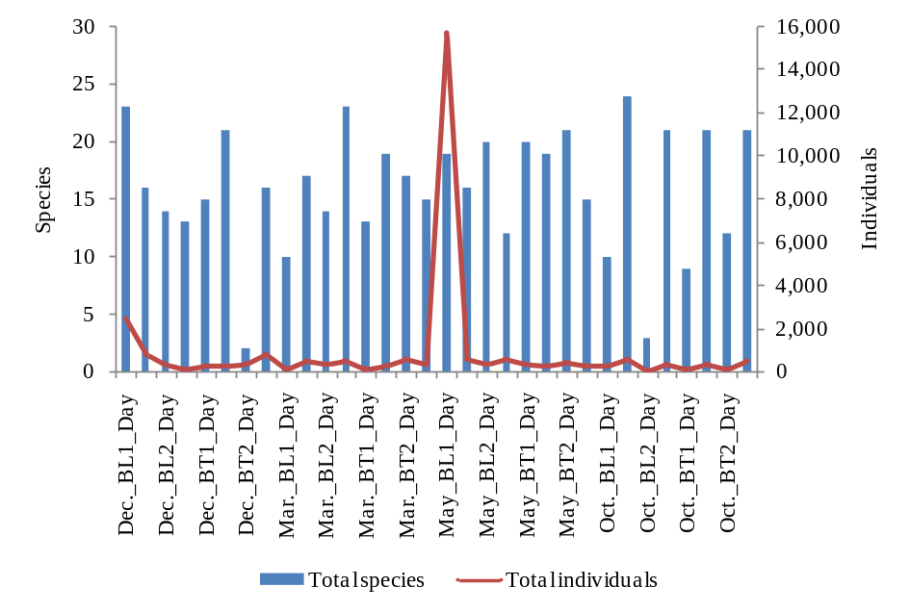
Fig. 2. Total number of species and individuals recorded at different sites, seasons and times of day

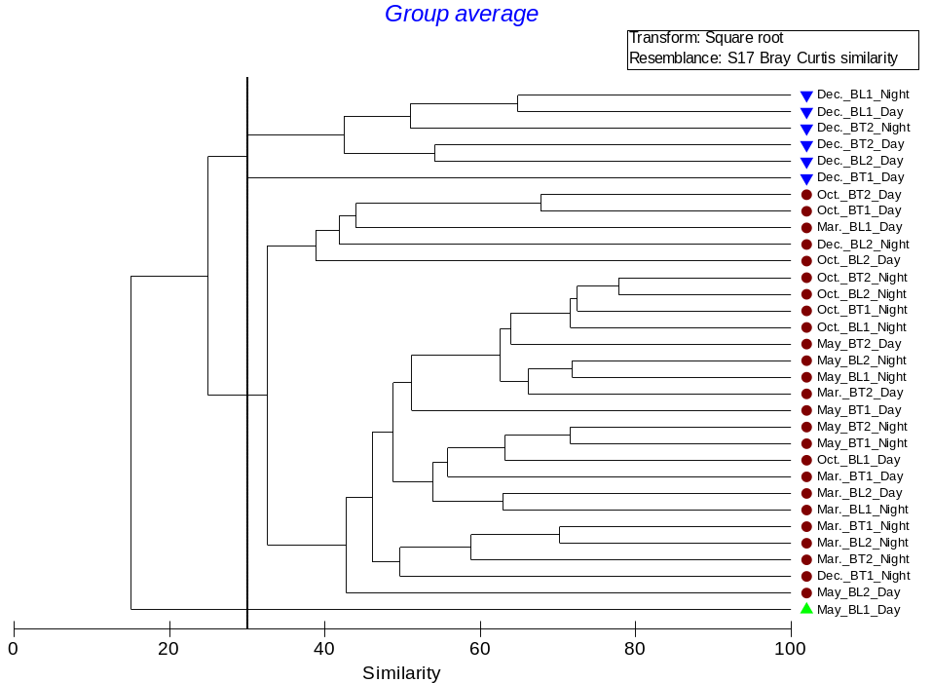
(a)
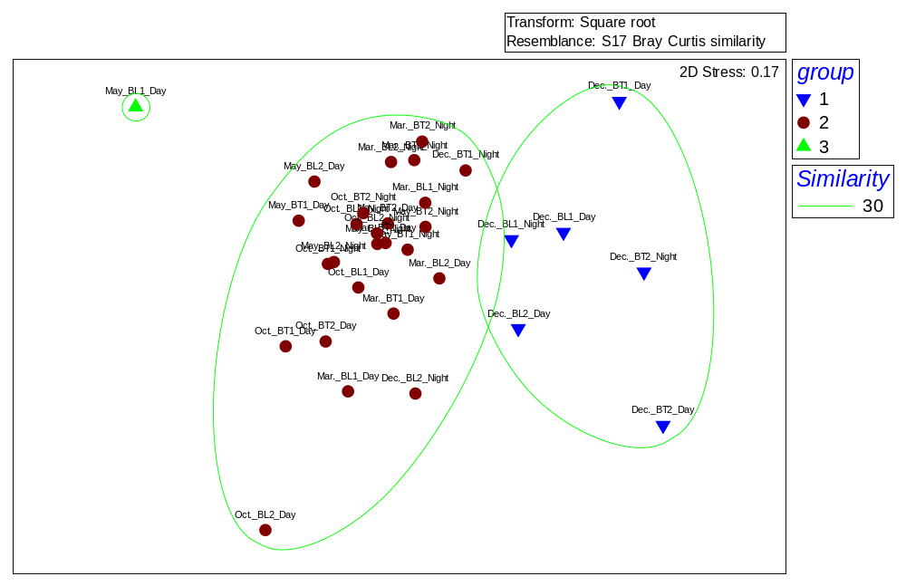
(b)
Fig. 3. a) Cluster analysis and b) Ordination (nMDS) of sampling sites, seasons and times of day based on species numerical abundance.

Of the environmental variables considered in this study, salinity had the greatest influence on fish species composition, abundance and distribution, which are often elicited as controls for seasonal patterns of species occurrence [18] Fishes that dominate the community in estuaries tend to have a broad salinity tolerance. Seasonal changes in tropical species communities are often very complex and may be a reflection of the breeding patterns, life history features, particularly recruitment [28]. In the Inner Gulf of Thailand, salinity is the driver of water density change. Annual salinity varies between 5 to 33 psu and extreme variation only occurs near rivermouths during the rainy season in the range of 22-32.5 psu, but there is a small fluctuation in the summer within the range 28-32.5 psu [35]. The highest value of salinity from the study was 26.60 being in March and the lowest was 6.00 in October. In the study, fish abundance was highest in the rainy season, also in general agreement with other studies [11, 28]. The rainy season coincided with the period of greatest recruitment of juvenile fishes and greatest zooplankton abundance in a mangrove estuary in tropical Australia [36]. The availability of prey for juvenile fishes in the Ban Laem coastal area would also increase in the rainy season, since crustacean larvae were most abundant at this time in other mangrove areas of Thailand [37]. Many fish species spawn during early summer, which coinsides with the influx of postlarvae and juveniles into estuarine areas in late summer after their planktonic phase [38]. From this study, salinity alone therefore, could not explain the differences in fish composition and abundance among seasons, because most fishes living in tropical estuaries are broadly euryhaline. Most of the species recorded probably have wide tolerance limits to the fluctuating conditions found in this system, therefore their ability to do so varies from species to species and hence influences their distribution. However, the observed distribution of a species in an estuary reflects its response to other factors as well, such as food availability, nutritional state, competition, predation, and habitat requirements [3].

IV. CONCLUSION
Mangrove ecosystems are important to the sustainable economic development of coastal fisheries. An understand of economic value is essential for the conservation of these important resources. The data presented herein showed a common characteristic for tropical estuarine fish communities in the Ban Laem coastal area, supports a rich fish fauna in terms of number of species and abundance, with 85.38% of the total fish recorded could be classified as resident and 57.41% are considered to be of economic importance. Also, these diverse fish assemblages have a high value for the local communities as a large proportion of the species (>30 species) are utilized by subsistence fisheries. Around more than half of the species collected were juveniles, supports the view of mangrove estuaries serving as nursery grounds. Many of the species those belong to the estuarine group support important coastal fisheries. Although Ban Laem coastal area has experienced by the anthropogenic stressors through coastal aquaculture, the role played by mangrove ecosystems in the life cycles of coastal marine fish remains significant. Therefore, the present study supports a more complete understanding of assemblages of fish and the relationships with coastal land use and seasonal patterns in the area, and the results can provide useful insights into both mangrove and fisheries resources management more effectively.

V. ACKNOWLEDGMENT
We are grateful to all students who assisted with field work. Thanks to Siriwan Suksri for assistance in data analysis. This study was financed through a scholarship of the Research Promotion and Technology Transfer Center (RPTTC), Faculty of Liberal Arts and Science, Kasetsart University.

VI. REFERENCES

[1] K. Ikejima, P. Tongnunui, T. Medej, and T. Taniuchi, “Juveniles and small fishes in a mangrove estuary in Trang province, Thailand: Season and habitat differences,” Estuar. Coast. Shelf Sci.. vol. 56, pp. 447-457, March 2003.
[2] I. Nagelkerken , S.J.M. Blaber, S. Bouillon, P. Green, M., Haywood, L.G. Kirton, J.O., Meynecke, J. Pawlik, H.M. Penrose, A. Sasekumar, and P.J. Somerfield, “The habitat function of mangroves for terrestrial and marine fauna: A review,” Aquat. Bot., vol. 89, pp. 155–185, December 2007.
[3] M.J. Kennish, Practical handbook of Marine Science, 2nd ed.:CRC Press, Boca Raton, FL, 1994, 566 p.
[4] C. Vidthayanon and S. Premcharoen, “The status of estuarine fish diversity in Thailand,” Mar. Freshwater. Res. Vol. 53, pp. 471-478, February 2002.
[5] S. Aksornkoae, N. Paphavasit, and G. Wattayakorn, “Mangroves of Thailand: Present status of conservation, use and management,” in The Economic and Environmental Values of Mangrove Forests and their Present State of Conservation in the South-East Asia/Pacific Region , B.F. Cough, B.F., Ed.: International Society of Mangrove Ecosystems, Okinawa, Japan, 1993, pp.83-133.
[6] S. Sudara, S. Satumanatpan, and S. Nateekanjanalarp, “Biodiversity of a newly established mangrove protected area at Samut Songkram Province,” in Proceeding of the third ASEAN-Australia symposium on living coastal resources, vol. 2, S. Sudara, C.R. Wilkinson and L.M. Chou, Eds.: Research paper.Chulalongkorn University, Bangkok, Thailand 1994,, pp.551-560.
[7] Department of Marine and Coastal Resources, Mangrove forest in Phetchaburi Province, Department of Marine and Coastal Resources, Ministry of Natural Resources and Environment, 2012.
[8] V. Chong, C. Sasekumar, M.U.C. Leh, and R. D’Cruz, “The fish and prawn communities of a Malaysian coastal mangrove system, with comparison to adjacent mudflats and inshore waters,” Estuar. Coast. Shelf Sci., vol. 31, pp. 703-722, November 1990.
[9] S. Poovachiranon and U. Satapoomin, “Occurrence of fish fauna associated in mangrove-seagrass habitats during the wet season, Phuket, Thailand,” in Proceeding of the third ASEAN-Australia symposium on living coastal resources, vol. 2, S. Sudara, C.R. Wilkinson and L.M. Chou, Eds.: Research paper.Chulalongkorn University, Bangkok, Thailand 1994, pp.539-550.
[10] A. Sasekumar, V.C. Chong, K.H. Lim and H. Singh, “The fish community of Matang waters. in Proceeding of the Third ASEAN-Australia Symposium on Living Coastal Resources, vol. 1, S. Sudara, C.R. Wilkinson and L.M. Chou, Eds. Status review, Chulalongkorn University, Bangkok, Thailand., 1994
[11] S. Hajisamae, and L.M. Chou, “Do shallow water habitats of impacted coastal strait serve as nursery grounds for fish fishes?,” Estuar. Coast. Shelf Sci., vol. 56(2), pp. 281-290, January 2002.
[12] S. Hajisamae, P. Yeesin, and S. Chaimongkol, “Habitat utilization by fishes in a shallow, semi-enclosed estuarine bay in southern Gulf of Thailand,” Estuar. Coast. Shelf Sci., vol. 68, pp. 647-655, July 2006.
[13] C.H. Faunce and J.F. Serafy, “Mangroves as fish habitat: 50 years of field studies,” Mar. Ecol. Prog. Ser., vol. 318, pp. 1-18, July 2006.
[14] FAO, FAO Species Identification Guide for Fishery Purposes, The Living Marine Resources of the Western Central Pacific, FAO, Rome., 2001.
[15] K.R. Clarke and R.N. Gorley, PRIMER v5 Users Manual/Tutorial, PRIMER-E, Plymouth, 2001.
[16] S. Hajisamae, P. Yeesin, and S. Chaimongkol, “Habitat utilization by fishes in a shallow, semi-enclosed estuarine bay in southern Gulf of Thailand,” Estuar. Coast. Shelf Sci., vol. 68, pp. 647-655, July 2006.
[17] S. Premcharoen, “Use of intertidal mangrove by juvenile fishes: the case of Mae Klong estuary, inner Gulf of Thailand,” Journal of Selçuk University Natural and Applied Science, ICOEST Conf. 2013 (Special Issue-2), pp. 794-807, 2013.
[18] A.K. Whitfield, Biology and ecology of fishes in Southern African estuaries. JLB Smith Institue of Ichthyology, Ichthyological Monograph No. 2, Grahamstown, South Africa, 1998.
[19] R.K.F. Unsworth, J. J. Bell, and D. J. Smith, “Tidal fish connectivity of reef and sea grass habitats in the Indo-Pacific,” J. Mar. Biol. Assoc. U. K., vol. 87, pp.1287–1296, July 2007.
[20] A.I. Robertson and S.J.M. Blaber, “Plankton, epibenthos and fish communities,” in Tropical Mangrove Ecosystem, A.I. Robertson and D.M., Eds. Washington DC: American Geophysical Union, 1992, pp. 173-224.
[21] J.L. McHugh, Estuarine nekton, in Estuaries, G.H. Lauff, Ed. Estuaries. American Association for the Advancement of Science Publication, 1967, pp. 581-620.
[22] P.C. Phillips, “Observation on abundance and spawning seasons of three fish families from El Salvador coastal lagoon,” Rev. Biol. Trop., vol. 31(1), pp. 29-36, September 1982.
[23] A. Yáñez-Arancibia, A.L. Lara-Domínguez, J.L. Rojas-Galaviz, P. Sánchez-Gil, J.W. Day, and C.J. Madden, “Seasonal biomass and diversity of estuarine fishes coupled with tropical habitat heterogeneity (southern Gulf of Mexico),” ‎J. Fish Biol., vol. 33, pp. 191-200, December 1988.
[24] D. Pauly and S. Wade-Pauly, An annotated bibliography of slipmouths (Pisces: Leiognathidae), Manila: ICLARM, 1981.
[25] D. Pauly, Theory and management of tropical, multispecies stocks: a review with emphasis on the Southwest Asian demersal fisheries, Manila: ICLARM, 1979.
[26] T. Wongratana, “Leiognathus pan., A new ponyfish (Pisces: Leiognathidae) from Thailand, with comment on Thai leiognathids,” Proc. Biol. Soc. Wash., vol. 101(3), pp. 496-502, 1988.

[27] P. Rönnbäck, M. Troell, N. Kautsky, and J.H. Primavera, “Distribution Pattern of Shrimps and Fish Among Avicennia and Rhizophora Microhabitats in the Pagbilao Mangroves,Philippines,” “ Estaurine, Coastal and Shelf Science 48, 223-234, February 1999.
[28] A.I. Robertson and N.C. Duke, “Mangrove fish-communities in tropical Queensland, Australia: spatial and temporal patterns in densities, biomass and community structure,” Mar. Biol., vol. 104, pp. 369-379, October 1990.
[29] T. V. Sankar , R. Anandan , S. Mathew , K. K. Asha , P. T. Lakshmanan , Jones Varkey , P. A. Aneesh, and B. P. Mohanty, “Chemical composition and nutritional value of Anchovy (Stolephorus commersonii) caught from Kerala coast, India,” Euro. J. Exp. Bio., vol. 3(1), pp. 85-89, 2013.
[30] J.S. Weis and P. Weis, “Use of intertidal mangrove and sea wall habitats by coral reef fishes in the Wakatobi Marine Park, Indonesia,” Raff. Bull. Zool., vol. 53(1), pp. 119-124, 2015.
[31] G.M. Newton, “Estuarine ichthyoplankton ecology in relation to hydrology and zooplankton dynamics in a salt-wedge estuary,” Mar. Freshw. Res.. vol. 47, pp. 99-111, 1996.
[32] L. Sanvicente-Anoeve, X. Chiappa-Carrara, and A. Ocana-Luna, “Spatio-temporal variation of ichthyoplankton assemblaes in two lagoon systems of the Mexican Caribbean,” Bull. Mar. Sci., vol. 70(1), pp. 19-32, January 2002.
[33] S.J.M. Blaber and D.A. Milton, “Species composition, community structure and zoogeography of fishes of mangrove estuaries in the Solomon Islands,” Mar. Biol., vol. 105, pp. 259-267, June 1990.
[34] A. Limsakul, S. Limjirakan, B. Suttamanuswong, “Asian summer monsoon and its associated rainfall availability in Thailand,” EnvironmentAsia, vol. 3, pp. 79-89, June 2010.
[35] T. Wiriwuttikorn, Long-term variations of nutrients in the Upper Gulf of Thailand, MSc thesis, Department of Environmental Science, Chulalongkorn University, Thailand, 1996.
[36] A.I. Robertson and N.C. Duke, “Recruitment, growth and residence time of fishes in a tropical Australia mangrove ecosystem,” Estuar. Coast. Shelf Sci., vol. 31, pp. 723-743, November 1990.
[37] P. Boonruang and V. Janekarn, “Distribution and abundance of penaeid postlarvae in mangrove areas along the east coast of Phuket Island, southern Thailand,” Phuket Mar. Biol. Res. Cent. Bull., vol.36, pp. 1-29, 1985.
[38] P. Laegdsgaard and C. Johnson, “Mangrove habitats as nurseries: Unique assemblages of juvenile fish in subtropical mangroves in eastern Australia,” Mar. Ecol. Prog. Ser.,vol. 126, pp. 67-81, March 1995.

